**Final Report**

*Evaluating the Efficacy of Various Machine Learning Architectures in Predicting Student Dropout and Academic Success*

Avery Li and Rem Turatbekov

Thomas Jefferson High School for Science and Technology

Machine Learning 1 TJ AV

Submitted in Partial Completion of Q1 Project, as a Continuation of Intermediate Report Submitted Previously

Director: Selma Yilmaz

Submitted: October 21, 2024

**Contents**

**1 Introduction: 4**

1.1 Intellectual Merit . . . . . . . . . . . . . . . . . . . . . . . . . . . . . . . . . . . . . . . . . . . . 4

1.2 Project Statement . . . . . . . . . . . . . . . . . . . . . . . . . . . . . . . . . . . . . . . . . . . . 4

**2 Data Report: 4**

2.1 Description of Dataset . . . . . . . . . . . . . . . . . . . . . . . . . . . . . . . . . . . . . . . . . 4

2.2 Data Preprocessing . . . . . . . . . . . . . . . . . . . . . . . . . . . . . . . . . . . . . . . . . . 5

**3 Data Mining: 5**

3.1 Current Issues . . . . . . . . . . . . . . . . . . . . . . . . . . . . . . . . . . . . . . . . . . . . . . . 5

3.2 Discarding Columns . . . . . . . . . . . . . . . . . . . . . . . . . . . . . . . . . . . . . . . . . . 6

3.3 Normalizing Quantitative Data . . . . . . . . . . . . . . . . . . . . . . . . . . . . . . . . . . 6

3.4 Train/Validation/Test Split . . . . . . . . . . . . . . . . . . . . . . . . . . . . . . . . . . . . . . 6

**4 Attribute Selection: 6**

4.1 CorrelationAttributeEval . . . . . . . . . . . . . . . . . . . . . . . . . . . . . . . . . . . . . . . 6

4.2 InfoGainAttributeEval . . . . . . . . . . . . . . . . . . . . . . . . . . . . . . . . . . . . . . . . . 7

4.3 GainRatioAttributeEval . . . . . . . . . . . . . . . . . . . . . . . . . . . . . . . . . . . . . . . . 8

4.4 OneRAttributeEval . . . . . . . . . . . . . . . . . . . . . . . . . . . . . . . . . . . . . . . . . . . 9

4.5 Intuition . . . . . . . . . . . . . . . . . . . . . . . . . . . . . . . . . . . . . . . . . . . . . . . . . . . . 9

**5 Classifier Models: 10**

5.1 J48 . . . . . . . . . . . . . . . . . . . . . . . . . . . . . . . . . . . . . . . . . . . . . . . . . . . . . . . . 10

5.2 NaiveBayes . . . . . . . . . . . . . . . . . . . . . . . . . . . . . . . . . . . . . . . . . . . . . . . . . 10

5.3 Logistic . . . . . . . . . . . . . . . . . . . . . . . . . . . . . . . . . . . . . . . . . . . . . . . . . . . . 11

5.4 Random Forest . . . . . . . . . . . . . . . . . . . . . . . . . . . . . . . . . . . . . . . . . . . . . . 12

**6 Results: 12**

6.1 CorrelationAttributeEval + J48 . . . . . . . . . . . . . . . . . . . . . . . . . . . . . . . . . . 12

6.2 CorrelationAttributeEval + Naive Bayes . . . . . . . . . . . . . . . . . . . . . . . . . . 12

6.3 CorrelationAttributeEval + Logistic . . . . . . . . . . . . . . . . . . . . . . . . . . . . . . 13

6.4 CorrelationAttributeEval + Random Forest . . . . . . . . . . . . . . . . . . . . . . . . 14

6.5 InfoGainAttributeEval + J48 . . . . . . . . . . . . . . . . . . . . . . . . . . . . . . . . . . . . 14

6.6 InfoGainAttributeEval + Naive Bayes . . . . . . . . . . . . . . . . . . . . . . . . . . . . . 15

6.7 InfoGainAttributeEval + Logistic . . . . . . . . . . . . . . . . . . . . . . . . . . . . . . . 15

6.8 InfoGainAttributeEval + Random Forest . . . . . . . . . . . . . . . . . . . . . . . . . . 16

6.9 GainRatioAttributeEval + J48 . . . . . . . . . . . . . . . . . . . . . . . . . . . . . . . . . . . 16

6.10 GainRatioAttributeEval + Naive Bayes . . . . . . . . . . . . . . . . . . . . . . . . . . . 17

6.11 GainRatioAttributeEval + Logistic . . . . . . . . . . . . . . . . . . . . . . . . . . . . . . . 17

6.12 GainRatioAttributeEval + Random Forest . . . . . . . . . . . . . . . . . . . . . . . . . 18

6.13 OneRAttributeEval + J48 . . . . . . . . . . . . . . . . . . . . . . . . . . . . . . . . . . . . . . 18

6.14 OneRAttributeEval + Naive Bayes . . . . . . . . . . . . . . . . . . . . . . . . . . . . . . . 19

6.15 OneRAttributeEval + Logistic . . . . . . . . . . . . . . . . . . . . . . . . . . . . . . . . . 19

6.16 OneRAttributeEval + Random Forest . . . . . . . . . . . . . . . . . . . . . . . . . . . . . 20

6.17 Intuition + J48 . . . . . . . . . . . . . . . . . . . . . . . . . . . . . . . . . . . . . . . . . . . . . . 20

6.18 Intuition + Naive Bayes . . . . . . . . . . . . . . . . . . . . . . . . . . . . . . . . . . . . . . 21

6.19 Intuition + Logistic . . . . . . . . . . . . . . . . . . . . . . . . . . . . . . . . . . . . . . . . . . 22

6.20 Intuition + Random Forest . . . . . . . . . . . . . . . . . . . . . . . . . . . . . . . . . . . . 22

**7 Analysis: 23**

7.1 General Analysis . . . . . . . . . . . . . . . . . . . . . . . . . . . . . . . . . . . . . . . . . . . . 23

7.2 TP/FP Rate . . . . . . . . . . . . . . . . . . . . . . . . . . . . . . . . . . . . . . . . . . . . . . . . . 23

7.3 Area Under Curve . . . . . . . . . . . . . . . . . . . . . . . . . . . . . . . . . . . . . . . . . . . 24

7.4 Best Performing Model . . . . . . . . . . . . . . . . . . . . . . . . . . . . . . . . . . . . . . . 24

**8 Conclusion: 24**

8.1 General Conclusion . . . . . . . . . . . . . . . . . . . . . . . . . . . . . . . . . . . . . . . . . . . 24

8.2 Insights / Further Exploration . . . . . . . . . . . . . . . . . . . . . . . . . . . . . . . . . 24

8.3 Division of Labor . . . . . . . . . . . . . . . . . . . . . . . . . . . . . . . . . . . . . . . . . . . . 25

**A Appendix A: Class Ordering 26**

A.1 Application Mode . . . . . . . . . . . . . . . . . . . . . . . . . . . . . . . . . . . . . . . . . . . . 26

A.2 Course . . . . . . . . . . . . . . . . . . . . . . . . . . . . . . . . . . . . . . . . . . . . . . . . . . . . . 26

A.3 Previous Qualifications . . . . . . . . . . . . . . . . . . . . . . . . . . . . . . . . . . . . . . . . 27

A.4 Nationality . . . . . . . . . . . . . . . . . . . . . . . . . . . . . . . . . . . . . . . . . . . . . . . . . . 27

A.5 Mother’s/Father’s Qualifications . . . . . . . . . . . . . . . . . . . . . . . . . . . . . . . . 28

A.6 Mother’s/Father’s Occupation . . . . . . . . . . . . . . . . . . . . . . . . . . . . . . . . . . 28

**B Appendix B: Preprocessing Code 29**

B.1 Semicolons to Commas . . . . . . . . . . . . . . . . . . . . . . . . . . . . . . . . . . . . . . . . 29

B.2 Converting to Binary Classification . . . . . . . . . . . . . . . . . . . . . . . . . . . . . . 30

B.3 Nominal to Ordinal Data . . . . . . . . . . . . . . . . . . . . . . . . . . . . . . . . . . . . . . . 30

B.4 Data Normalization . . . . . . . . . . . . . . . . . . . . . . . . . . . . . . . . . . . . . . . . . . . 31

**C Appendix C: Attribute Selection Results 31**

C.1 CorrelationAttributeEval . . . . . . . . . . . . . . . . . . . . . . . . . . . . . . . . . . . . . . . 31

C.2 InfoGainAttributeEval . . . . . . . . . . . . . . . . . . . . . . . . . . . . . . . . . . . . . . . . . 32

C.3 GainRatioAttributeEval . . . . . . . . . . . . . . . . . . . . . . . . . . . . . . . . . . . . . . . . 33

C.4 OneRAttributeEval . . . . . . . . . . . . . . . . . . . . . . . . . . . . . . . . . . . . . . . . . . . 34

**D Appendix D: Model Performance: 35**

D.1 Overall Performance . . . . . . . . . . . . . . . . . . . . . . . . . . . . . . . . . . . . . . . . . . 35

D.2 By Accuracy . . . . . . . . . . . . . . . . . . . . . . . . . . . . . . . . . . . . . . . . . . . . . . . . 36

D.3 By Dropout TP Rate . . . . . . . . . . . . . . . . . . . . . . . . . . . . . . . . . . . . . . . . . . . 37

D.3 By Area Under ROC Curve . . . . . . . . . . . . . . . . . . . . . . . . . . . . . . . . . . . . . 37

**E Appendix E: Replication 38**

E.1 Attribute Selection . . . . . . . . . . . . . . . . . . . . . . . . . . . . . . . . . . . . . . . . . . . . 38

E.2 Classifier Algorithms . . . . . . . . . . . . . . . . . . . . . . . . . . . . . . . . . . . . . . . . . . 38

**9 References** . . . . . . . . . . . . . . . . . . . . . . . . . . . . . . . . . . . . . . . . . . . . . . . . . . . . . . . . 40

**1 Introduction:**

**1.1 Intellectual Merit**

Our research stems from an ongoing discussion of the prevalence of dropouts in recent years, heightened by the COVID-19 pandemic. A student’s success in the workforce is largely dependent on their ability to achieve a higher education, especially in our time of such an oversaturated job market. Thus, it is necessary to analyze the potential of dropouts to ensure the success of students at various levels of education. We gather data from various higher education institutions regarding the performance of students in their respective schools, taking into account absenteeism, grades, and other factors to try and predict a student’s dropout and academic success.

**1.2 Project Statement**

It is imperative that we are able to predict student dropout to plan appropriate intervention if necessary. In this project, we aim to construct a categorical classification machine learning model that learns to classify a student as one of three statuses—dropout, enrolled, and graduate. After taking steps to clean the data and sort it down to its core attributes, we hope to construct a model to be able to map a student’s statistics to their academic success at a certain institution. Several factors will be considered, including a student’s grades, the days they were absent, age of enrollment, as well as external factors, including scholarship and financial status.

**2 Data Report:**

Data was taken from UCI, a website dedicated to various datasets. The specific dataset was funded by program SATDAP, and data was collected across various higher education institutions, which was acquired through various disjoint databases and compiled into a comprehensive dataset: ​​<https://archive.ics.uci.edu/dataset/697/predict+students+dropout+and+academic+success>

**2.1 Description of Dataset**

The dataset has a total of 36 attributes, ranging from information about the student to information about their personal background. A comprehensive list of all the attributes as well as their meaning, if necessary, follows. The dataset includes Marital Status, Application mode (type of application to the school), Application order, Course, Daytime/evening attendance, Previous qualification, Previous qualification (grade), Nationality, Mother's qualification, Father's qualification, Mother's occupation, Father's occupation, Admission grade, Displaced, Educational special needs, Debtor, Tuition fees up to date, Gender, Scholarship holder, Age at enrollment, International, Curricular units 1st sem (credited), Curricular units 1st sem (enrolled), Curricular units 1st sem (evaluations), Curricular units 1st sem (grade), Curricular units 1st sem (approved), Curricular units 1st sem (without evaluations), Curricular units 2nd sem (credited), Curricular units 2nd sem (enrolled), Curricular units 2nd sem (evaluations), Curricular units 2nd sem (approved), Curricular units 2nd sem (grade),Curricular units 2nd sem (without evaluations), Unemployment rate, Inflation rate, GDP, and finally our class attribute, Target. A single instance can therefore be more aptly described as a student-situation pair (accounting for GDP, unemployment rate, etc…), rather than just a student. There are a total of 4424 instances of these student-situation pairs in this dataset, each representative of a student at some institution.

The distribution of the class is fairly uniform, with around 33% of each class type. There are no missing values in this dataset, but we have received approval to continue on with our project in spite of this.

**2.2 Data Preprocessing**

First we would need to normalize all our data points. This proves to be somewhat of a difficult task, as some data is nominal qualitative, disguised as ordinal qualitative data, and so figuring out the relative significance, or lack thereof, of each data. Another problem is figuring out which attributes relate to each other. The grades earned in a semester and the relationship between evaluations and without evaluations might be proportional, so we should figure out these relationships in order to reduce our data size. The next step would be figuring out which attributes have low correlation, and select an appropriate amount of attributes from there.

**3 Data Mining:**

**3.1 Current Issues**

**Issue 1**: The data was initially delimited by semicolons instead of commas, making the data unreadable in the CSV format. Code is detailed in Appendix B.1.

**Issue 2**: Many of the attributes in this dataset are inherently nominal qualitative (Nationality, Marital Status, Mother qualifications) with seemingly random integer numbers assigned to each unique value of each attribute, creating a false sense of order that the original data does not imply. We resolve the issue by understanding the meaning, then fixing the values as strings they corresponded to. Code is detailed in Appendix B.2.

**Issue 3**: Additional classification is taxing on the model itself, and is not our intended goal. The dataset has 3 classes total—dropout, graduate, enrolled—with the latter two representing a non-dropout. Our goal is not to predict the distinction between graduate and enrolled; therefore, we merge the two classes into a single “Non_Dropout” class, making our model a binary classification problem instead. The proportion is now relatively balanced, but the difference in size between the two classes must be accounted for when splitting the dataset. Code is detailed in Appendix B.3.

**3.2 Discarding Columns**

The easiest columns to remove were those of derived attributes or ones that clearly had no impact on dropout rate. The attribute “International” in our case refers to “Non-portuguese”, with a one-to-one ratio to Nationality. Since the Nationality attribute provides more information, we can remove the International column.

**3.3 Normalizing Quantitative Data**

Much of our data is nominal, rather than ordinal data, so we disregard any qualitative implications they may have otherwise had. However, other qualitative variables need to be normalized. Those attributes are Admission grade, Age at enrollment, all attributes with the prefix Curricular units, Unemployment rate, GDP, and Inflation rate. All were normalized to a scale from 0 to 5 through decimal scaling, and all the rest were normalized to the same scale through simple normalization. Code is detailed in Appendix B.4.

**3.4 Weka Cross Validation**

Our data is not very large, numbering just over 4,000 instances after preprocessing. Instead of splitting between training, validation, and test sets, we use Weka’s stratified 10-fold cross validation to measure the performance of our classification models by taking the average of the accuracy obtained from each fold. While this algorithm is computationally expensive, it does not waste much data, as can be the case when fixing an arbitrary validation set, and is superior to the repeated holdout method since every instance is guaranteed to be used for both training and testing.

**4 Attribute Selection:**

Our dataset is left with 36 attributes after preprocessing. Each of the following attribute selection algorithms are performed on Weka, with the exception of pure intuition, which has its own subsection. The chosen attribute selection algorithms are CorrelationAttributeEval, GainRatioAttributeEval, InfoGainAttributeEval, and OneRAttributeEval. A detailed description of each follows. A description of how to perform each evaluation is provided in Appendix E.1.

**4.1 CorrelationAttributeEval**

The Pearson Correlation Coefficient between an attribute x and target y is calculated by:

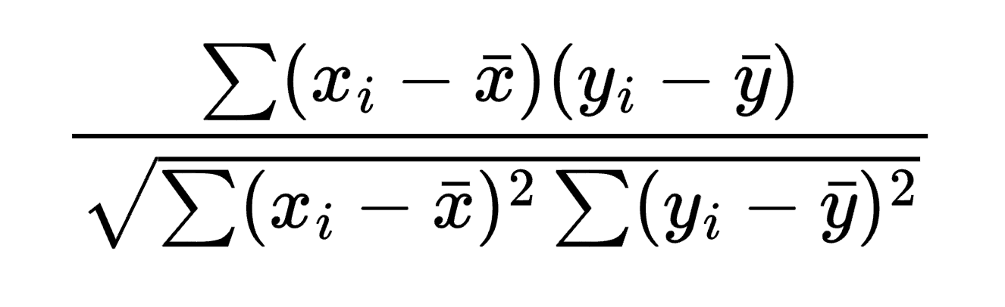

The value r calculated by this formula ranges from -1 to 1, inclusive, with 0 being the worst possible outcome representing no correlation. We chose to select all attributes with an absolute r-value greater than 0.075, leaving us with 21 attributes. The full analysis is found in Appendix C.1 and selected attributes are shown below:

Curricular units 2nd sem (grade)

Curricular units 2nd sem (approved)

Curricular units 1st sem (grade)

Curricular units 1st sem (approved)

Tuition fees up to date

Age at enrollment

Scholarship holder

Debtor

Gender

Curricular units 2nd sem (evaluations)

Curricular units 2nd sem (enrolled)

Previous qualification

Application mode

Curricular units 1st sem (enrolled)

Marital status

Displaced

Admission grade

Curricular units 1st sem (evaluations)

Daytime/evening attendance

Curricular units 2nd sem (without evaluations)

Previous qualification (grade)

**4.2 InfoGainAttributeEval**

Information gain is a metric given by the entropy of certain subsets of data in a decision table. Entropy of any dataset is given by:

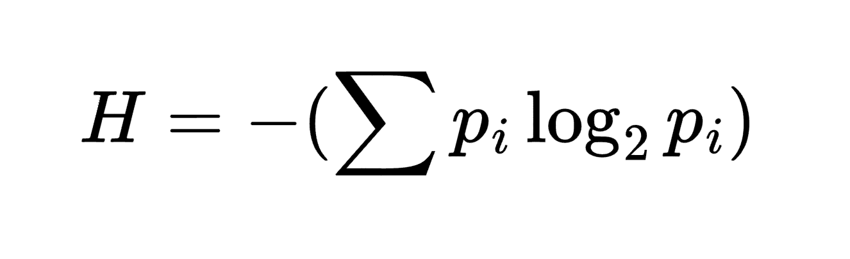

where *pi* is the proportion of the label to the dataset.

Information gain is then calculated by the proportion difference in entropies:

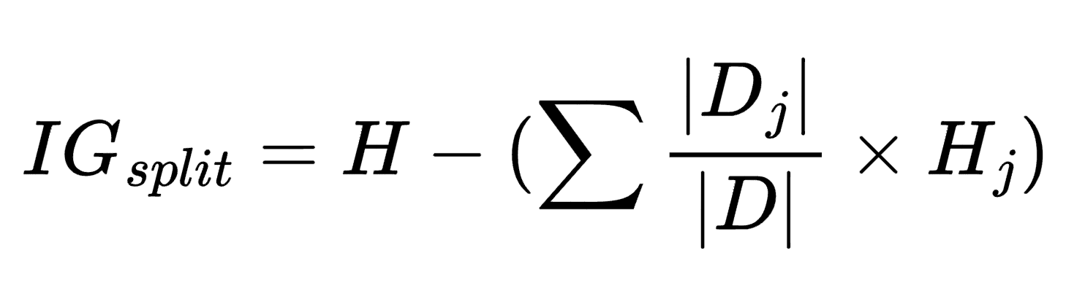

This formula implies that the information gain is the difference between the entropy of the output class and the weighted entropies of a single class decision tree; the higher the information gain, the better the predictor. We decide to choose all attributes with an *IGsplit* value of greater than .025, leaving 20 attributes in the dataset. The full analysis is found in Appendix C.2 and selected attributes are shown below:

Curricular units 2nd sem (approved)

Curricular units 2nd sem (grade)

Curricular units 1st sem (approved)

Curricular units 1st sem (grade)

Tuition fees up to date

Curricular units 2nd sem (evaluations)

Curricular units 1st sem (evaluations)

Age at enrollment

Application mode

Course

Scholarship holder

Previous qualification (grade)

Debtor

Mother_occupation

Curricular units 2nd sem (enrolled)

Previous qualification

Gender

Father_qualification

Father_occupation

Mother_qualification

**4.3 GainRatioAttributeEval**

Gain ratio is an attempt at lessening certain biases by using the information gain metric mentioned in section 4.2; We introduce a new metric, Intrinsic Information:

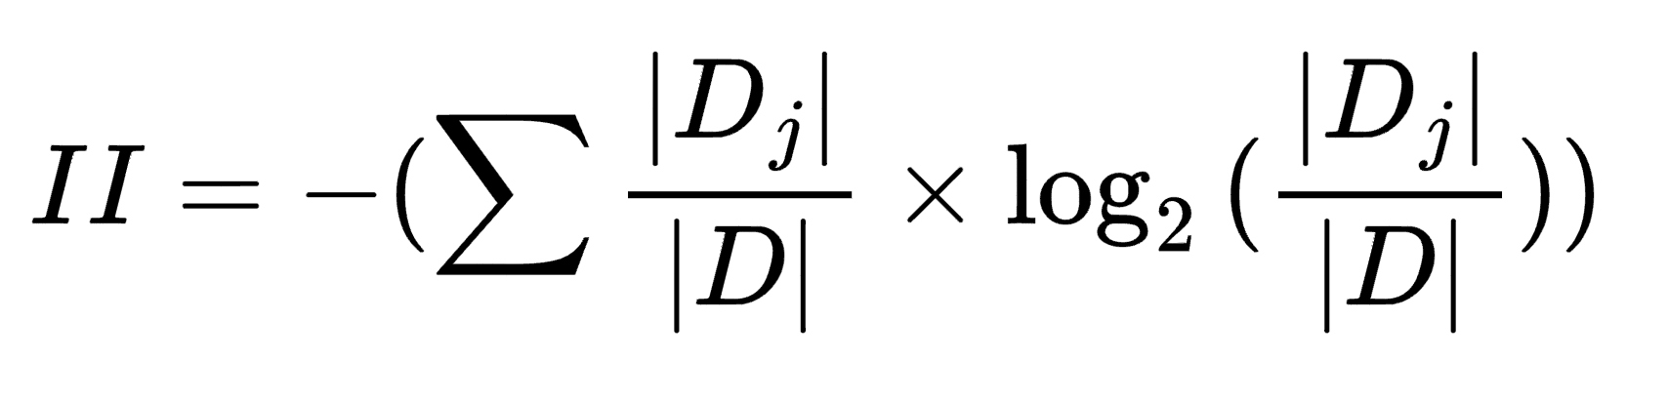

or, in other words, the entropy of the proportions of the subcategories themselves.

Given this metric, the gain ratio is calculated as

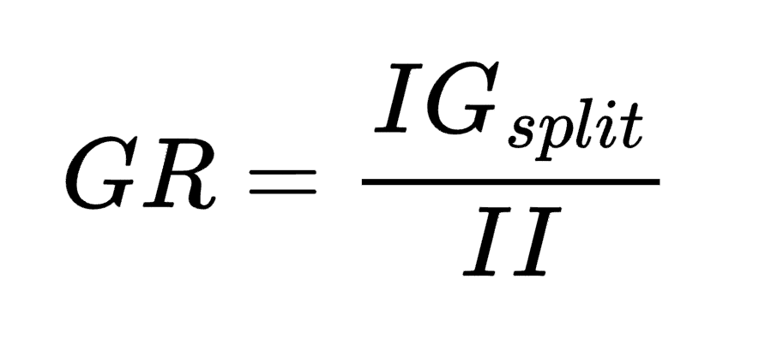

We choose all attributes with a GR value greater than .14, leaving us with 21 attributes. The full analysis is found in Appendix C.3 and selected attributes are shown below:

Tuition fees up to date

Curricular units 2nd sem (grade)

Curricular units 2nd sem (approved)

Curricular units 1st sem (approved)

Curricular units 1st sem (grade)

Debtor

Scholarship holder

Curricular units 2nd sem (evaluations)

Age at enrollment

Curricular units 1st sem (evaluations)

Gender

Previous qualification

Application mode

Curricular units 1st sem (without evaluations)

Curricular units 2nd sem (without evaluations)

Admission grade

Curricular units 2nd sem (enrolled)

Previous qualification (grade)

Nacionality

Curricular units 1st sem (enrolled)

Marital status

**4.4 OneRAttributeEval**

OneR is an algorithm designed to choose the best attribute with a one-to-one ratio of the class labels. The algorithm is as follows:

for each attribute:

for each unique value in attribute:

count labels for instances with the unique value

determine most frequent label

assign value to label

compute error rate given rule chosen

choose rule with lowest error rate

We choose all attributes with resulting value greater than 68%, leaving us with 19 attributes. The full analysis is found in Appendix C.4 and selected attributes are shown below:

Curricular units 2nd sem (approved)

Curricular units 2nd sem (grade)

Curricular units 1st sem (approved)

Curricular units 1st sem (grade)

Tuition fees up to date

Curricular units 2nd sem (evaluations)

Curricular units 1st sem (evaluations)

Debtor

Application mode

Age at enrollment

Mother_occupation

Previous qualification

Previous qualification (grade)

Father_qualification

Mother_qualification

Father_occupation

Curricular units 1st sem (enrolled)

Curricular units 2nd sem (enrolled)

Course

**4.5 Intuition**

Intuitively, a student’s grades in the semester is likely the largest driving factor for whether they drop out. Thus, we select 12 Curricular Unit attributes. Additionally, we consider financial and personal factors—special needs, debtor, tuition fee up to date—all to be important. Selected attributes are shown below:

Curricular units 1st sem (credited)

Curricular units 1st sem (enrolled)

Curricular units 1st sem (evaluations)

Curricular units 1st sem (without evaluations)

Curricular units 1st sem (approved)

Curricular units 1st sem (grade)

Curricular units 2nd sem (credited)

Curricular units 2nd sem (enrolled)

Curricular units 2nd sem (evaluations)

Curricular units 2nd sem (without evaluations)

Curricular units 2nd sem (approved)

Curricular units 2nd sem (grade)

Educational special needs

Debtor

Tuition fees up to date

Displaced

Gender

Age at enrollment

Scholarship holder

Daytime/evening attendance

**5 Classifier Models:**

After choosing the attributes, we run various models on the dataset in Weka to test for efficiency. The four classifier models we selected are J48, NaiveBayes, Logistic, and Random Forest. A brief description of each model follows.

**5.1 J48**

J48 is a decision tree algorithm that uses entropy to measure information gain and subsequently construct a decision tree. At each iteration, the algorithm splits the tree using the attribute with the greatest information gain, typically finding a near-optimal classifier.

**5.2 NaiveBayes**

NaiveBayes is a statistical predictor operating under the Bayes’ Theorem:

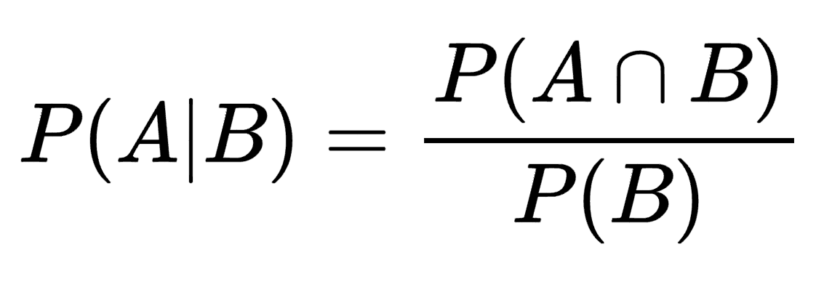

The probability for a certain attribute *X* with unique values *xi* for a class label *Ci* is given by

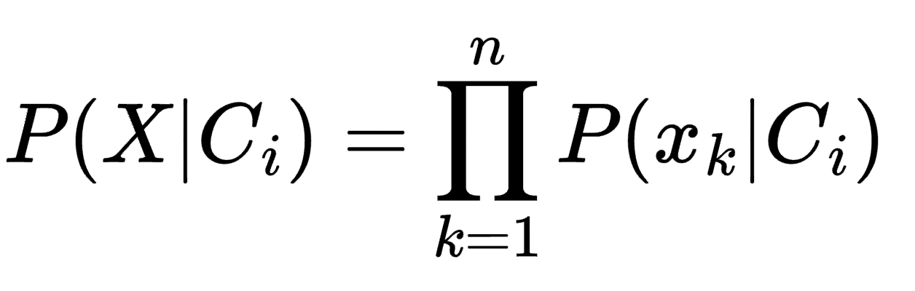

The model uses this value to determine the correct probability distribution for prediction.

**5.3 Logistic Regression**

The idea is to make linear regression also produce probabilities. Logistic Regression directly estimates class probabilities for both continuous and discrete data, but is typically used for binary classifications; often, a threshold will be set where a prediction of greater than 50% probability results in a positive classification. The algorithm uses a weighted linear sum embedded in a multidimensional logit transform. The probability is given by:

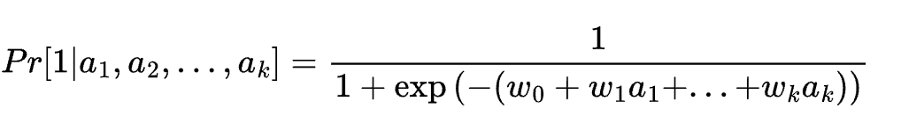

Considering only one dimension, or one variable, a1, the resulting graph of the output Pr[1|a1] ranges from 0 to 1 and takes form of an S-shape characteristic of the sigmoid function:

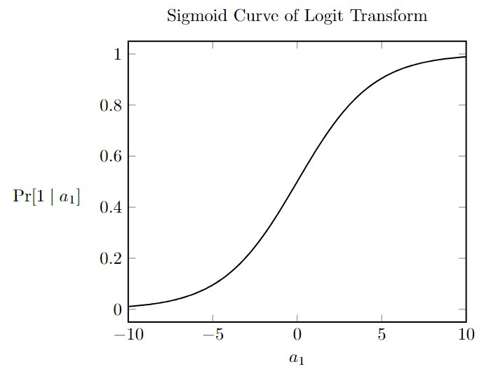

The basis of logistic regression is to choose weights to maximize the log-likelihood, which measures how well the model predicts the actual outcomes in the training data. The function to be maximized is shown below:



**5.4 Random Forest**

Random Forest instantiates a number of classification trees and uses the output of each to determine a total classification for the model. The trees are randomly generated and equally weighted so that a single tree cannot dominate the entire forest. The trees are independent of each other, and are collectively used to evaluate the output of the model.

**6 Results:**

The results of our analysis are shown. Each subsection is a combination of attribute selection/classifier model pair, evaluated on accuracy and other metrics through 10-fold cross validation. Result output is pasted directly from Weka. The steps taken are detailed in section E.2.

**6.1 CorrelationAttributeEval + J48**

=== Stratified cross-validation ===

=== Summary ===

Correctly Classified Instances 3821 86.3698 %

Incorrectly Classified Instances 603 13.6302 %

Kappa statistic 0.6745

Mean absolute error 0.1998

Root mean squared error 0.3433

Relative absolute error 45.8262 %

Root relative squared error 73.5169 %

Total Number of Instances 4424

=== Detailed Accuracy By Class ===

TP Rate FP Rate Precision Recall F-Measure MCC ROC Area PRC Area

Dropout 0.712 0.065 0.839 0.712 0.770 0.679 0.848 0.742

Non_Dropout 0.935 0.288 0.873 0.935 0.903 0.679 0.848 0.871

WeightedAvg 0.864 0.216 0.862 0.864 0.860 0.679 0.848 0.830

=== Confusion Matrix ===

a b <-- classified as

1012 409 | a = Dropout

194 2809 | b = Non_Dropout

**6.2 CorrelationAttributeEval + NaiveBayes**

=== Stratified cross-validation ===

=== Summary ===

Correctly Classified Instances 3701 83.6573 %

Incorrectly Classified Instances 723 16.3427 %

Kappa statistic 0.615

Mean absolute error 0.1669

Root mean squared error 0.3829

Relative absolute error 38.261 %

Root relative squared error 82.0077 %

Total Number of Instances 4424

=== Detailed Accuracy By Class ===

TP_Rate FP_Rate Precision Recall F-Measure MCC ROC_Area PRC_Area

Dropout 0.695 0.097 0.773 0.695 0.732 0.617 0.872 0.771

Non_Dropout 0.903 0.305 0.862 0.903 0.882 0.617 0.872 0.916

WeightedAvg 0.837 0.238 0.834 0.837 0.834 0.617 0.872 0.869

=== Confusion Matrix ===

a b <-- classified as

988 433 | a = Dropout

290 2713 | b = Non_Dropout

**6.3 CorrelationAttributeEval + Logistic**

=== Stratified cross-validation ===

=== Stratified cross-validation ===

=== Summary ===

Correctly Classified Instances 3848 86.9801 %

Incorrectly Classified Instances 576 13.0199 %

Kappa statistic 0.6868

Mean absolute error 0.1918

Root mean squared error 0.3127

Relative absolute error 43.976 %

Root relative squared error 66.9732 %

Total Number of Instances 4424

=== Detailed Accuracy By Class ===

TP_Rate FP_Rate Precision Recall F-Measure MCC ROC_Area PRC_Area

Dropout 0.709 0.054 0.861 0.709 0.778 0.693 0.909 0.856

Non_Dropout 0.946 0.291 0.873 0.946 0.908 0.693 0.909 0.933

WeightedAvg 0.870 0.215 0.869 0.870 0.866 0.693 0.909 0.908

=== Confusion Matrix ===

a b <-- classified as

1007 414 | a = Dropout

162 2841 | b = Non_Dropout

**6.4 CorrelationAttributeEval + RandomForest**

=== Stratified cross-validation ===

=== Summary ===

Correctly Classified Instances 3829 86.5506 %

Incorrectly Classified Instances 595 13.4494 %

Kappa statistic 0.6784

Mean absolute error 0.209

Root mean squared error 0.3211

Relative absolute error 47.926 %

Root relative squared error 68.7733 %

Total Number of Instances 4424

=== Detailed Accuracy By Class ===

TP_Rate FP_Rate Precision Recall F-Measure MCC ROC_Area PRC_Area

Dropout 0.713 0.062 0.844 0.713 0.773 0.683 0.906 0.857

Non_Dropout 0.938 0.287 0.873 0.938 0.904 0.683 0.906 0.939

WeightedAvg 0.866 0.215 0.864 0.866 0.862 0.683 0.906 0.913

=== Confusion Matrix ===

a b <-- classified as

1013 408 | a = Dropout

187 2816 | b = Non_Dropout

**6.5 InfoGainAttributeEval + J48**

=== Stratified cross-validation ===

=== Summary ===

Correctly Classified Instances 3811 86.1438 %

Incorrectly Classified Instances 613 13.8562 %

Kappa statistic 0.666

Mean absolute error 0.2099

Root mean squared error 0.3369

Relative absolute error 48.1292 %

Root relative squared error 72.1505 %

Total Number of Instances 4424

=== Detailed Accuracy By Class ===

TP_Rate FP_Rate Precision Recall F-Measure MCC ROC_Area PRC_Area

Dropout 0.692 0.058 0.849 0.692 0.762 0.673 0.865 0.788

Non_Dropout 0.942 0.308 0.866 0.942 0.902 0.673 0.865 0.892

WeightedAvg 0.861 0.228 0.860 0.861 0.857 0.673 0.865 0.859

=== Confusion Matrix ===

a b <-- classified as

983 438 | a = Dropout

175 2828 | b = Non_Dropout

**6.6 InfoGainAttributeEval + NaiveBayes**

=== Stratified cross-validation ===

=== Summary ===

Correctly Classified Instances 3746 84.6745 %

Incorrectly Classified Instances 678 15.3255 %

Kappa statistic 0.6404

Mean absolute error 0.1615

Root mean squared error 0.3734

Relative absolute error 37.0444 %

Root relative squared error 79.9595 %

Total Number of Instances 4424

=== Detailed Accuracy By Class ===

TP_Rate FP_Rate Precision Recall F-Measure MCC ROC_Area PRC_Area

Dropout 0.719 0.093 0.786 0.719 0.751 0.642 0.884 0.795

Non_Dropout 0.907 0.281 0.872 0.907 0.889 0.642 0.884 0.930

WeightedAvg 0.847 0.221 0.844 0.847 0.845 0.642 0.884 0.887

=== Confusion Matrix ===

a b <-- classified as

1021 400 | a = Dropout

278 2725 | b = Non_Dropout

**6.7 InfoGainAttributeEval + Logistic**

=== Stratified cross-validation ===

=== Summary ===

Correctly Classified Instances 3847 86.9575 %

Incorrectly Classified Instances 577 13.0425 %

Kappa statistic 0.6891

Mean absolute error 0.1877

Root mean squared error 0.3196

Relative absolute error 43.0331 %

Root relative squared error 68.4516 %

Total Number of Instances 4424

=== Detailed Accuracy By Class ===

TP_Rate FP_Rate Precision Recall F-Measure MCC ROC_Area PRC_Area

Dropout 0.725 0.062 0.847 0.725 0.781 0.693 0.900 0.818

Non_Dropout 0.938 0.275 0.878 0.938 0.907 0.693 0.900 0.922

WeightedAvg 0.870 0.207 0.868 0.870 0.867 0.693 0.900 0.889

=== Confusion Matrix ===

a b <-- classified as

1030 391 | a = Dropout

186 2817 | b = Non_Dropout

**6.8 InfoGainAttributeEval + Random Forest**

=== Stratified cross-validation ===

=== Summary ===

Correctly Classified Instances 3832 86.6184 %

Incorrectly Classified Instances 592 13.3816 %

Kappa statistic 0.6777

Mean absolute error 0.2235

Root mean squared error 0.3201

Relative absolute error 51.2404 %

Root relative squared error 68.5588 %

Total Number of Instances 4424

=== Detailed Accuracy By Class ===

TP_Rate FP_Rate Precision Recall F-Measure MCC ROC_Area PRC_Area

Dropout 0.701 0.056 0.856 0.701 0.771 0.685 0.908 0.866

Non_Dropout 0.944 0.299 0.870 0.944 0.905 0.685 0.908 0.935

WeightedAvg 0.866 0.221 0.865 0.866 0.862 0.685 0.908 0.913

=== Confusion Matrix ===

a b <-- classified as

996 425 | a = Dropout

167 2836 | b = Non_Dropout

**6.9 GainRatioAttributeEval + J48**

=== Stratified cross-validation ===

=== Summary ===

Correctly Classified Instances 3810 86.1212 %

Incorrectly Classified Instances 614 13.8788 %

Kappa statistic 0.6681

Mean absolute error 0.2032

Root mean squared error 0.3438

Relative absolute error 46.5987 %

Root relative squared error 73.6234 %

Total Number of Instances 4424

=== Detailed Accuracy By Class ===

TP_Rate FP_Rate Precision Recall F-Measure MCC ROC_Area PRC_Area

Dropout 0.706 0.065 0.837 0.706 0.766 0.673 0.849 0.751

Non_Dropout 0.935 0.294 0.870 0.935 0.901 0.673 0.849 0.873

WeightedAvg 0.861 0.221 0.860 0.861 0.858 0.673 0.849 0.834

=== Confusion Matrix ===

a b <-- classified as

1003 418 | a = Dropout

196 2807 | b = Non_Dropout

**6.10 GainRatioAttributeEval + NaiveBayes**

=== Stratified cross-validation ===

=== Summary ===

Correctly Classified Instances 3715 83.9738 %

Incorrectly Classified Instances 709 16.0262 %

Kappa statistic 0.6212

Mean absolute error 0.1649

Root mean squared error 0.3813

Relative absolute error 37.8097 %

Root relative squared error 81.6571 %

Total Number of Instances 4424

=== Detailed Accuracy By Class ===

TP_Rate FP_Rate Precision Recall F-Measure MCC ROC_Area PRC_Area

Dropout 0.694 0.091 0.783 0.694 0.736 0.623 0.873 0.768

Non_Dropout 0.909 0.306 0.863 0.909 0.885 0.623 0.873 0.916

WeightedAvg 0.840 0.237 0.837 0.840 0.837 0.623 0.873 0.869

=== Confusion Matrix ===

a b <-- classified as

986 435 | a = Dropout

274 2729 | b = Non_Dropout

**6.11 GainRatioAttributeEval + Logistic**

=== Stratified cross-validation ===

=== Summary ===

Correctly Classified Instances 3844 86.8897 %

Incorrectly Classified Instances 580 13.1103 %

Kappa statistic 0.6842

Mean absolute error 0.1927

Root mean squared error 0.316

Relative absolute error 44.1853 %

Root relative squared error 67.6687 %

Total Number of Instances 4424

=== Detailed Accuracy By Class ===

TP_Rate FP_Rate Precision Recall F-Measure MCC ROC_Area PRC_Area

Dropout 0.705 0.054 0.862 0.705 0.776 0.691 0.903 0.844

Non_Dropout 0.946 0.295 0.872 0.946 0.907 0.691 0.903 0.923

WeightedAvg 0.869 0.217 0.868 0.869 0.865 0.691 0.903 0.898

=== Confusion Matrix ===

a b <-- classified as

1002 419 | a = Dropout

161 2842 | b = Non_Dropout

**6.12 GainRatioAttributeEval + Random Forest**

=== Stratified cross-validation ===

=== Summary ===

Correctly Classified Instances 3831 86.5958 %

Incorrectly Classified Instances 593 13.4042 %

Kappa statistic 0.6787

Mean absolute error 0.2082

Root mean squared error 0.3208

Relative absolute error 47.7497 %

Root relative squared error 68.7113 %

Total Number of Instances 4424

=== Detailed Accuracy By Class ===

TP_Rate FP_Rate Precision Recall F-Measure MCC ROC_Area PRC_Area

Dropout 0.709 0.060 0.848 0.709 0.773 0.684 0.904 0.857

Non_Dropout 0.940 0.291 0.872 0.940 0.905 0.684 0.904 0.937

WeightedAvg 0.866 0.217 0.865 0.866 0.862 0.684 0.904 0.9118

=== Confusion Matrix ===

a b <-- classified as

1008 413 | a = Dropout

180 2823 | b = Non_Dropout

**6.13 OneRAttributeEval + J48**

=== Stratified cross-validation ===

=== Summary ===

Correctly Classified Instances 3803 85.9629 %

Incorrectly Classified Instances 621 14.0371 %

Kappa statistic 0.6609

Mean absolute error 0.2125

Root mean squared error 0.3382

Relative absolute error 48.7244 %

Root relative squared error 72.4251 %

Total Number of Instances 4424

=== Detailed Accuracy By Class ===

TP_Rate FP_Rate Precision Recall F-Measure MCC ROC_Area PRC_Area

Dropout 0.685 0.058 0.848 0.685 0.758 0.668 0.862 0.792

Non_Dropout 0.942 0.315 0.864 0.942 0.901 0.668 0.862 0.890

WeightedAvg 0.860 0.232 0.859 0.860 0.855 0.668 0.862 0.859

=== Confusion Matrix ===

a b <-- classified as

974 447 | a = Dropout

174 2829 | b = Non_Dropout

**6.14 OneRAttributeEval + NaiveBayes**

=== Stratified cross-validation ===

=== Summary ===

Correctly Classified Instances 3742 84.5841 %

Incorrectly Classified Instances 682 15.4159 %

Kappa statistic 0.6373

Mean absolute error 0.1628

Root mean squared error 0.3755

Relative absolute error 37.3264 %

Root relative squared error 80.4178 %

Total Number of Instances 4424

=== Detailed Accuracy By Class ===

TP_Rate FP_Rate Precision Recall F-Measure MCC ROC_Area PRC_Area

Dropout 0.712 0.091 0.788 0.712 0.748 0.639 0.878 0.788

Non_Dropout 0.909 0.288 0.870 0.909 0.889 0.639 0.878 0.920

WeightedAvg 0.846 0.225 0.843 0.846 0.844 0.639 0.878 0.878

=== Confusion Matrix ===

a b <-- classified as

1012 409 | a = Dropout

273 2730 | b = Non_Dropout

**6.15 OneRAttributeEval + Logistic**

=== Stratified cross-validation ===

=== Summary ===

Correctly Classified Instances 3845 86.9123 %

Incorrectly Classified Instances 579 13.0877 %

Kappa statistic 0.687

Mean absolute error 0.1893

Root mean squared error 0.3208

Relative absolute error 43.397 %

Root relative squared error 68.7127 %

Total Number of Instances 4424

=== Detailed Accuracy By Class ===

TP_Rate FP_Rate Precision Recall F-Measure MCC ROC_Area PRC_Area

Dropout 0.719 0.060 0.851 0.719 0.779 0.692 0.899 0.813

Non_Dropout 0.940 0.281 0.876 0.940 0.907 0.692 0.899 0.920

WeightedAvg 0.869 0.210 0.868 0.869 0.866 0.692 0.899 0.886

=== Confusion Matrix ===

a b <-- classified as

1021 400 | a = Dropout

179 2824 | b = Non_Dropout

**6.16 OneRAttributeEval + Random Forest**

=== Stratified cross-validation ===

=== Summary ===

Correctly Classified Instances 3831 86.5958 %

Incorrectly Classified Instances 593 13.4042 %

Kappa statistic 0.6761

Mean absolute error 0.2225

Root mean squared error 0.3213

Relative absolute error 51.0158 %

Root relative squared error 68.8185 %

Total Number of Instances 4424

=== Detailed Accuracy By Class ===

TP_Rate FP_Rate Precision Recall F-Measure MCC ROC_Area PRC_Area

Dropout 0.695 0.053 0.861 0.695 0.769 0.684 0.906 0.864

Non_Dropout 0.947 0.305 0.868 0.947 0.906 0.684 0.906 0.933

WeightedAvg 0.866 0.224 0.866 0.866 0.862 0.684 0.906 0.910

=== Confusion Matrix ===

a b <-- classified as

987 434 | a = Dropout

159 2844 | b = Non_Dropout

**6.17 Intuition + J48**

=== Stratified cross-validation ===

=== Summary ===

Correctly Classified Instances 3778 85.3978 %

Incorrectly Classified Instances 646 14.6022 %

Kappa statistic 0.6546

Mean absolute error 0.1944

Root mean squared error 0.353

Relative absolute error 44.5829 %

Root relative squared error 75.592 %

Total Number of Instances 4424

=== Detailed Accuracy By Class ===

TP_Rate FP_Rate Precision Recall F-Measure MCC ROC_Area PRC_Area

Dropout 0.715 0.080 0.808 0.715 0.759 0.657 0.845 0.721

Non_Dropout 0.920 0.285 0.872 0.920 0.895 0.657 0.845 0.869

WeightedAvg 0.854 0.219 0.852 0.854 0.851 0.657 0.845 0.822

=== Confusion Matrix ===

a b <-- classified as

1016 405 | a = Dropout

241 2762 | b = Non_Dropout

**6.18 Intuition + NaiveBayes**

=== Stratified cross-validation ===

=== Summary ===

Correctly Classified Instances 3715 83.9738 %

Incorrectly Classified Instances 709 16.0262 %

Kappa statistic 0.6194

Mean absolute error 0.1655

Root mean squared error 0.3803

Relative absolute error 37.9508 %

Root relative squared error 81.4399 %

Total Number of Instances 4424

=== Detailed Accuracy By Class ===

TP_Rate FP_Rate Precision Recall F-Measure MCC ROC_Area PRC_Area

Dropout 0.685 0.087 0.788 0.685 0.733 0.623 0.860 0.755

Non_Dropout 0.913 0.315 0.860 0.913 0.885 0.623 0.860 0.895

WeightedAvg 0.840 0.242 0.837 0.840 0.837 0.623 0.860 0.850

=== Confusion Matrix ===

a b <-- classified as

974 447 | a = Dropout

262 2741 | b = Non_Dropout

**6.19 Intuition + Logistic**

=== Stratified cross-validation ===

=== Summary ===

Correctly Classified Instances 3872 87.5226 %

Incorrectly Classified Instances 552 12.4774 %

Kappa statistic 0.7011

Mean absolute error 0.1913

Root mean squared error 0.3097

Relative absolute error 43.8767 %

Root relative squared error 66.3223 %

Total Number of Instances 4424

=== Detailed Accuracy By Class ===

TP_Rate FP_Rate Precision Recall F-Measure MCC ROC_Area PRC_Area

Dropout 0.725 0.054 0.865 0.725 0.789 0.707 0.914 0.87

Non_Dropout 0.946 0.275 0.879 0.946 0.911 0.707 0.914 0.945

WeightedAvg 0.875 0.204 0.874 0.875 0.872 0.707 0.914 0.921

=== Confusion Matrix ===

a b <-- classified as

1030 391 | a = Dropout

161 2842 | b = Non_Dropout

**6.20 Intuition + Random Forest**

=== Stratified cross-validation ===

=== Summary ===

Correctly Classified Instances 3846 86.9349 %

Incorrectly Classified Instances 578 13.0651 %

Kappa statistic 0.6878

Mean absolute error 0.1969

Root mean squared error 0.3149

Relative absolute error 45.1578 %

Root relative squared error 67.4462 %

Total Number of Instances 4424

=== Detailed Accuracy By Class ===

TP_Rate FP_Rate Precision Recall F-Measure MCC ROC_Area PRC_Area

Dropout 0.720 0.060 0.850 0.720 0.780 0.693 0.911 0.864

Non_Dropout 0.940 0.280 0.876 0.940 0.907 0.693 0.911 0.940

WeightedAvg 0.869 0.209 0.868 0.869 0.866 0.693 0.911 0.916

=== Confusion Matrix ===

a b <-- classified as

1023 398 | a = Dropout

180 2823 | b = Non_Dropout

**7 Analysis:**

A detailed sorting of the performance of each model by certain metrics is found in Appendix D, along with all results mentioned in this section.

**7.1 General Analysis**

After running 20 different models on our dataset, we found that the five best-performing models by accuracy are:

1. Intuition + Logistic
2. Correlation + Logistic
3. InfoGain + Logistic
4. Intuition + Random Forest
5. OneR + Logistic

These models achieved a minimum accuracy of 86.9%, with Intuition + Logistic performing best at 87.5% accuracy. Although we cannot say that this model is most optimal before observing other metrics, we can assume these five models are acceptable to use.

Interestingly enough, it turned out that a model’s accuracy was largely dependent on the type of classification model used, rather than the attribute selection algorithm. Logistic models tended to perform best, followed by Random Forest, J48, and Naive Bayes. Therefore, Logistic models should be used if aiming for highest accuracy.

**7.2 TP/FP Rate**

It is not wise to only consider accuracy as the metric in choosing the best model. Our model aims to predict student dropout, not success, which means that a better focus metric would be the true positive rate of dropout. It is better to incorrectly predict a non-dropout student as dropout, rather than the opposite, as the goal of the project is toy. Hence, the true positive rate is the most important metric, taking into account all instances labeledas positive. The five best-performing models by TPR are:

1. Intuition + Logistic
2. Intuition + Random Forest
3. OneR + Logistic
4. InfoGain + Naive Bayes
5. Intuition + J48

These models achieve a minimum TPR of .710, with the highest being Intuition + Logistic at .875 TPR. Overall, the list is more closely associated with the attribute selection algorithm than to the classifier itself. Intuitively selected attributes tend to perform best, but the trend is scattered and weak, if present at all.

**7.3 Area Under Curve**

Since both FPs and FNs are important, area under the ROC curve is a satisfactory measure of the model’s performance. The top five models by the area under curve (AUC) metric are:

1. Intuition + Logistic
2. Intuition + Random Forest
3. Correlation + Logistic
4. InfoGain + Random Forest
5. Correlation + Random Forest

The top five models achieve a minimum AUC of .906, with Intuition + Logistic performing highest at .914 AUC.

**7.4 Best Model**

After examining three different metrics, we conclude that the Intuition + Logistic model is best as it outperformed all other models in every metric, achieving 87.5% accuracy, .875 TPR, and .914 AUC. Most importantly, it achieved the highest performance for TPR, our primary metric of interest for dropout prediction.

**8 Conclusion:**

**8.1 Insights**

This project gave us firsthand experience of the machine learning workflow for supervised learning. During preprocessing, we faced numerous difficulties and had to learn to troubleshoot errors in our data along with issues from the Weka software. For data analysis, we learned the importance of attribute selection through various selection algorithms paired with classifier models. Despite the apparent ease in choosing accuracy as the primary metric, we had to observe various metrics to evaluate model performance pertinent to the context and choose the best model more assuredly; we used Accuracy, True Positive Rate, and Area Under Curve of ROC to evaluate 20 models and compare them holistically in terms of student dropout.

**8.2 Future Research**

We only used four of the eleven available selection algorithms in WEKA, but there are many other attribute selection algorithms not included, such as Minimum Redundancy Maximum Relevance and Recursive Feature Elimination. This leads to many more model possibilities, so our chosen model is by no means the definitive best model. Future research can explore these other combinations, and with additional data, like mental health and extracurricular engagement, the predictors for student dropout and academic success can be examined more comprehensively. Beyond the current methodology employed, the nature of the study can be altered, as longitudinal studies could provide valuable insight into how the predictive factors evolve over time in our rapidly changing world.

**8.3 Division of Labor**

Rem Turatbekov:

1. Finding data
2. Code for preprocessing
3. Editing reports
4. Presentation

Avery Li:

1. Drafting Reports
2. Running Models on Weka
3. Formatting code in paper
4. Finding External Resources

**A Appendix A: Class Ordering:**

Following are the conversion of integer value to the actual value they represent in the data table, formatted as a python dictionary. The contents of the dictionaries are used in Appendix B.3, as detailed in section 3.1.

**A.1 Application Mode**

data = {

"1": "1st phase - general contingent",

"2": "Ordinance No. 612/93",

"5": "1st phase - special contingent (Azores Island)",

"7": "Holders of other higher courses",

"10": "Ordinance No. 854-B/99",

"15": "International student (bachelor)",

"16": "1st phase - special contingent (Madeira Island)",

"17": "2nd phase - general contingent",

"18": "3rd phase - general contingent",

"26": "Ordinance No. 533-A/99, item b2) (Different Plan)",

"27": "Ordinance No. 533-A/99, item b3 (Other Institution)",

"39": "Over 23 years old",

"42": "Transfer",

"43": "Change of course",

"44": "Technological specialization diploma holders",

"51": "Change of institution/course",

"53": "Short cycle diploma holders",

"57": "Change of institution/course (International)"

}

**A.2 Course**

data = {

"33": "Biofuel Production Technologies",

"171": "Animation and Multimedia Design",

"8014": "Social Service (evening attendance)",

"9003": "Agronomy",

"9070": "Communication Design",

"9085": "Veterinary Nursing",

"9119": "Informatics Engineering",

"9130": "Equinculture",

"9147": "Management",

"9238": "Social Service",

"9254": "Tourism",

"9500": "Nursing",

"9556": "Oral Hygiene",

"9670": "Advertising and Marketing Management",

"9773": "Journalism and Communication",

"9853": "Basic Education",

"9991": "Management (evening attendance)"

}

**A.3 Previous Qualifications**

data = {

"1": "Secondary education",

"2": "Higher education - bachelor's degree",

"3": "Higher education - degree",

"4": "Higher education - master's",

"5": "Higher education - doctorate",

"6": "Frequency of higher education",

"9": "12th year of schooling - not completed",

"10": "11th year of schooling - not completed",

"12": "Other - 11th year of schooling",

"14": "10th year of schooling",

"15": "10th year of schooling - not completed",

"19": "Basic education 3rd cycle (9th/10th/11th year) or equiv.",

"38": "Basic education 2nd cycle (6th/7th/8th year) or equiv.",

"39": "Technological specialization course",

"40": "Higher education - degree (1st cycle)",

"42": "Professional higher technical course",

"43": "Higher education - master (2nd cycle)"

}

**A.4 Nationality**

data = {

"1": "Portuguese",

"2": "German",

"6": "Spanish",

"11": "Italian",

"13": "Dutch",

"14": "English",

"17": "Lithuanian",

"21": "Angolan",

"22": "Cape Verdean",

"24": "Guinean",

"25": "Mozambican",

"26": "Santomean",

"32": "Turkish",

"41": "Brazilian",

"62": "Romanian",

"100": "Moldova (Republic of)",

"101": "Mexican",

"103": "Ukrainian",

"105": "Russian",

"108": "Cuban",

"109": "Colombian"

}

**A.5 Mother’s/Father’s Qualifications**

data = {

"1": "Secondary Education - 12th Year of Schooling or Eq.",

"2": "Higher Education - Bachelor's Degree",

"3": "Higher Education - Degree",

"4": "Higher Education - Master's",

"5": "Higher Education - Doctorate",

"6": "Frequency of Higher Education",

"9": "12th Year of Schooling - Not Completed",

"10": "11th Year of Schooling - Not Completed",

"11": "7th Year (Old)",

"12": "Other - 11th Year of Schooling",

"14": "10th Year of Schooling",

"18": "General commerce course",

"19": "Basic Education 3rd Cycle (9th/10th/11th Year) or Equiv.",

"22": "Technical-professional course",

"26": "7th year of schooling",

"27": "2nd cycle of the general high school course",

"29": "9th Year of Schooling - Not Completed",

"30": "8th year of schooling",

"34": "Unknown",

"35": "Can't read or write",

"36": "Can read without having a 4th year of schooling",

"37": "Basic education 1st cycle (4th/5th year) or equiv.",

"38": "Basic Education 2nd Cycle (6th/7th/8th Year) or Equiv.",

"39": "Technological specialization course",

"40": "Higher education - degree (1st cycle)",

"41": "Specialized higher studies course",

"42": "Professional higher technical course",

"43": "Higher Education - Master (2nd cycle)",

"44": "Higher Education - Doctorate (3rd cycle)"

}

**A.6 Mother’s/Father’s Occupation**

data = {

"0": "Student",

"1": "Representatives of the Legislative Power and Executive Bodies, Directors, Directors and Executive Managers",

"2": "Specialists in Intellectual and Scientific Activities",

"3": "Intermediate Level Technicians and Professions",

"4": "Administrative staff",

"5": "Personal Services, Security and Safety Workers and Sellers",

"6": "Farmers and Skilled Workers in Agriculture, Fisheries and Forestry",

"7": "Skilled Workers in Industry, Construction and Craftsmen",

"8": "Installation and Machine Operators and Assembly Workers",

"9": "Unskilled Workers",

"10": "Armed Forces Professions",

"90": "Other Situation",

"99": "(blank)",

"122": "Health professionals",

"123": "Teachers",

"125": "Specialists in information and communication technologies (ICT)",

"131": "Intermediate level science and engineering technicians and professions",

"132": "Technicians and professionals, of intermediate level of health",

"134": "Intermediate level technicians from legal, social, sports, cultural and similar services",

"141": "Office workers, secretaries in general and data processing operators",

"143": "Data, accounting, statistical, financial services and registry-related operators",

"144": "Other administrative support staff",

"151": "Personal service workers",

"152": "Sellers",

"153": "Personal care workers and the like",

"171": "Skilled construction workers and the like, except electricians",

"173": "Skilled workers in printing, precision instrument manufacturing, jewelers, artisans and the like",

"175": "Workers in food processing, woodworking, clothing and other industries and crafts",

"191": "Cleaning workers",

"192": "Unskilled workers in agriculture, animal production, fisheries and forestry",

"193": "Unskilled workers in extractive industry, construction, manufacturing and transport",

"194": "Meal preparation assistants"

}

All changes from integer to string are made in appendix B.3

**B Appendix B: Preprocessing Code:**

The following provides code snippets for certain tasks needed to be accomplished during preprocessing, for sake of replication. Any code in section B.3 onwards should have the first and last few lines of B.3 appended for file reading/writing.

**B.1 Semicolons to Commas**

Changing data delimiter to comma from semicolon:

with open("data.csv", encoding="utf-8-sig") as file:

f = file.read().replace(';', ',').replace('"','').replace('\t','').replace("'s","")

with open("new_data.csv", "w") as file:

file.write(f)

**B.2 Converting Integer to Strings**

In reference to section 3.1, taking data from Appendix A

mappings = [

("Marital status", marital_status),

("Application mode", application_mode),

("Course", course),

("Previous qualification", prev_qualification),

("Nacionality", nacionality),

("Mother_qualification", mother_qualification),

("Father_qualification", father_qualification),

("Mother_occupation", mother_occupation),

("Father_occupation", father_occupation)

]

def main():

with open("data.csv") as f:

data = [l.strip().split(";") for l in f]

ind_mapper = {}

print(data[0])

for attr_name, mapper in mappings:

ind_mapper[data[0].index(attr_name)] = mapper

for l in data[1:]:

for ind, mapper in ind_mapper.items():

l[ind] = mapper[int

(l[ind])]

with open("out_data.csv", "w") as f:

for l in data:

f.write(",".join(l)+"\n")

**B.3 Converting to Binary Classification**

All code of reading the file and writing to a new file is included here once, but removed in future references for sake of brevity; fields will always be given by the list fields, rows by list rows, and import csv is always implied.

import csv

rows = []

with open("data.csv", "r") as f:

csvreader = csv.reader(f)

fields = next(csvreader)

for row in csvreader:

rows.append(row)

data = []

for row in rows:

if row[-1] in ['Graduate', 'Enrolled']:

row[-1] = 'Non_Dropout'

data.append({fields[i]: row[i] for i in range(len(fields))})

with open('data_out.csv', 'w', newline='') as csvfile:

writer = csv.DictWriter(csvfile, fieldnames=fields)

writer.writeheader()

writer.writerows(data)

**B.4 Data Normalization**

In reference to section 3.3

NEWMIN = 0

NEWMAX = 5

fields_to_change = [12, *range(19, 35)] #detailed list found in 3.4

for idx in fields_to_change:

vals = [float(row[idx]) for row in rows]

minval = min(vals); maxval = max(vals)

for row in rows:

row[idx] = str((float(row[idx])-minval)/(maxval-minval) * (NEWMAX-NEWMIN) + NEWMIN)

**C Appendix C: Attribute Selection Results:**

The following details the complete result of 4 different attribute selection analyses, pasted from Weka.

**C.1 CorrelationAttributeEval**

=== Attribute Selection on all input data ===

Search Method:

Attribute ranking.

Attribute Evaluator (supervised, Class (nominal): 36 Target):

Correlation Ranking Filter

Ranked attributes:

0.57179 31 Curricular units 2nd sem (grade)

0.5695 30 Curricular units 2nd sem (approved)

0.48067 25 Curricular units 1st sem (grade)

0.47911 24 Curricular units 1st sem (approved)

0.42915 17 Tuition fees up to date

0.25422 20 Age at enrollment

0.24535 19 Scholarship holder

0.22941 16 Debtor

0.20398 18 Gender

0.155 29 Curricular units 2nd sem (evaluations)

0.14151 28 Curricular units 2nd sem (enrolled)

0.13806 6 Previous qualification

0.13316 2 Application mode

0.12463 22 Curricular units 1st sem (enrolled)

0.11039 1 Marital status

0.10723 14 Displaced

0.09581 13 Admission grade

0.09012 23 Curricular units 1st sem (evaluations)

0.0805 5 Daytime/evening attendance

0.0799 32 Curricular units 2nd sem (without evaluations)

0.07821 7 Previous qualification (grade)

0.07049 3 Application order

0.06487 4 Course

0.05423 26 Curricular units 1st sem (without evaluations)

0.05006 9 Mother_qualification

0.04632 35 GDP

0.04378 10 Father_qualification

0.03304 27 Curricular units 2nd sem (credited)

0.02931 21 Curricular units 1st sem (credited)

0.02783 34 Inflation rate

0.02336 11 Mother_occupation

0.02204 12 Father_occupation

0.01298 33 Unemployment rate

0.01037 8 Nacionality

0.00281 15 Educational special needs

Selected attributes: 31,30,25,24,17,20,19,16,18,29,28,6,2,22,1,14,13,23,5,32,7,3,4,26,9,35,10,27,21,34,11,12,33,8,15 : 35

**C.2 InfoGainAttributeEval**

=== Attribute Selection on all input data ===

Search Method:

Attribute ranking.

Attribute Evaluator (supervised, Class (nominal): 36 Target):

Information Gain Ranking Filter

Ranked attributes:

0.31227 30 Curricular units 2nd sem (approved)

0.24983 31 Curricular units 2nd sem (grade)

0.24574 24 Curricular units 1st sem (approved)

0.17996 25 Curricular units 1st sem (grade)

0.12686 17 Tuition fees up to date

0.0927 29 Curricular units 2nd sem (evaluations)

0.07577 23 Curricular units 1st sem (evaluations)

0.06836 20 Age at enrollment

0.06402 2 Application mode

0.04985 4 Course

0.04913 19 Scholarship holder

0.04354 7 Previous qualification (grade)

0.03519 16 Debtor

0.03422 11 Mother_occupation

0.03185 28 Curricular units 2nd sem (enrolled)

0.03137 6 Previous qualification

0.02945 18 Gender

0.02923 10 Father_qualification

0.02909 12 Father_occupation

0.029 9 Mother_qualification

0.02271 22 Curricular units 1st sem (enrolled)

0.01107 13 Admission grade

0.00918 1 Marital status

0.00828 14 Displaced

0.0052 3 Application order

0.00448 5 Daytime/evening attendance

0.004 35 GDP

0.00373 8 Nacionality

0.00357 32 Curricular units 2nd sem (without evaluations)

0.00257 26 Curricular units 1st sem (without evaluations)

0 15 Educational special needs

0 33 Unemployment rate

0 34 Inflation rate

0 21 Curricular units 1st sem (credited)

0 27 Curricular units 2nd sem (credited)

Selected attributes: 30,31,24,25,17,29,23,20,2,4,19,7,16,11,28,6,18,10,12,9,22,13,1,14,3,5,35,8,32,26,15,33,34,21,27 : 35

**C.3 GainRatioAttributeEval**

=== Attribute Selection on all input data ===

Search Method:

Attribute ranking.

Attribute Evaluator (supervised, Class (nominal): 36 Target):

Gain Ratio feature evaluator

Ranked attributes:

0.2405 17 Tuition fees up to date

0.13978 31 Curricular units 2nd sem (grade)

0.12913 30 Curricular units 2nd sem (approved)

0.10939 24 Curricular units 1st sem (approved)

0.09234 25 Curricular units 1st sem (grade)

0.06887 16 Debtor

0.06074 19 Scholarship holder

0.05893 29 Curricular units 2nd sem (evaluations)

0.04429 20 Age at enrollment

0.03889 23 Curricular units 1st sem (evaluations)

0.03147 18 Gender

0.02889 6 Previous qualification

0.02435 2 Application mode

0.02414 26 Curricular units 1st sem (without evaluations)

0.02408 32 Curricular units 2nd sem (without evaluations)

0.01932 13 Admission grade

0.01896 28 Curricular units 2nd sem (enrolled)

0.01876 7 Previous qualification (grade)

0.01496 8 Nacionality

0.01461 22 Curricular units 1st sem (enrolled)

0.01439 1 Marital status

0.01297 4 Course

0.01161 11 Mother_occupation

0.01084 10 Father_qualification

0.01055 9 Mother_qualification

0.00901 5 Daytime/evening attendance

0.00842 12 Father_occupation

0.00833 14 Displaced

0.00578 3 Application order

0.00469 35 GDP

0 27 Curricular units 2nd sem (credited)

0 33 Unemployment rate

0 34 Inflation rate

0 15 Educational special needs

0 21 Curricular units 1st sem (credited)

Selected attributes: 17,31,30,24,25,16,19,29,20,23,18,6,2,26,32,13,28,7,8,22,1,4,11,10,9,5,12,14,3,35,27,33,34,15,21 : 35

**C.4 OneRAttributeEval**

=== Attribute Selection on all input data ===

Search Method:

Attribute ranking.

Attribute Evaluator (supervised, Class (nominal): 36 Target):

OneR feature evaluator.

Using 10 fold cross validation for evaluating attributes.

Minimum bucket size for OneR: 6

Ranked attributes:

83.16 30 Curricular units 2nd sem (approved)

80.8092 31 Curricular units 2nd sem (grade)

80.0633 24 Curricular units 1st sem (approved)

78.2098 25 Curricular units 1st sem (grade)

76.6049 17 Tuition fees up to date

73.1465 29 Curricular units 2nd sem (evaluations)

71.3834 23 Curricular units 1st sem (evaluations)

70.6148 16 Debtor

70.5018 2 Application mode

70.0497 20 Age at enrollment

69.9367 11 Mother_occupation

69.8463 6 Previous qualification

69.6203 7 Previous qualification (grade)

69.3942 10 Father_qualification

69.2812 9 Mother_qualification

69.0778 12 Father_occupation

68.6483 22 Curricular units 1st sem (enrolled)

68.3318 28 Curricular units 2nd sem (enrolled)

68.1736 4 Course

67.9928 32 Curricular units 2nd sem (without evaluations)

67.925 26 Curricular units 1st sem (without evaluations)

67.8797 5 Daytime/evening attendance

67.8797 3 Application order

67.8797 35 GDP

67.8797 18 Gender

67.8797 19 Scholarship holder

67.8797 34 Inflation rate

67.8797 15 Educational special needs

67.8797 14 Displaced

67.8797 33 Unemployment rate

67.8119 27 Curricular units 2nd sem (credited)

67.8119 1 Marital status

67.7667 8 Nacionality

67.6763 21 Curricular units 1st sem (credited)

65.8002 13 Admission grade

Selected attributes: 30,31,24,25,17,29,23,16,2,20,11,6,7,10,9,12,22,28,4,32,26,5,3,35,18,19,34,15,14,33,27,1,8,21,13 : 35

**D Appendix D: Model Performance:**

The following is a neater formatting of the results listed in section 6.

**D.1 Overall Performance**

| **Model Name** | **Accuracy** | **TP Dropout** | **FP Dropout** | **ROC** | **TP Total** | **FP Total** |
| --- | --- | --- | --- | --- | --- | --- |
| CorrJ48 | 0.863698 | 0.712 | 0.065 | 0.848 | 0.864 | 0.216 |
| CorrNaive | 0.836573 | 0.695 | 0.097 | 0.872 | 0.837 | 0.238 |
| CorrLogistic | 0.869801 | 0.709 | 0.054 | 0.909 | 0.87 | 0.215 |
| CorrRF | 0.865506 | 0.713 | 0.062 | 0.906 | 0.866 | 0.215 |
| InfoJ48 | 0.861438 | 0.692 | 0.058 | 0.865 | 0.861 | 0.228 |
| InfoNaive | 0.846745 | 0.719 | 0.093 | 0.884 | 0.847 | 0.221 |
| InfoLogistic | 0.869575 | 0.6891 | 0.062 | 0.9 | 0.87 | 0.207 |
| InfoRF | 0.866184 | 0.701 | 0.056 | 0.908 | 0.866 | 0.221 |
| GainJ48 | 0.861212 | 0.706 | 0.065 | 0.849 | 0.869 | 0.221 |
| GainNaive | 0.839738 | 0.694 | 0.091 | 0.873 | 0.84 | 0.237 |
| GainLogistic | 0.868897 | 0.705 | 0.054 | 0.903 | 0.869 | 0.217 |
| GainRF | 0.865958 | 0.709 | 0.06 | 0.904 | 0.866 | 0.217 |
| OneRJ48 | 0.859629 | 0.685 | 0.058 | 0.862 | 0.86 | 0.232 |
| OneRNaive | 0.845841 | 0.712 | 0.091 | 0.878 | 0.846 | 0.225 |
| OneRLogistic | 0.869123 | 0.719 | 0.06 | 0.899 | 0.869 | 0.21 |
| OneRRF | 0.865958 | 0.695 | 0.053 | 0.906 | 0.866 | 0.224 |
| IntuitJ48 | 0.853978 | 0.715 | 0.08 | 0.845 | 0.854 | 0.219 |
| IntuitNaive | 0.839738 | 0.685 | 0.087 | 0.86 | 0.84 | 0.242 |
| IntuitLogistic | 0.875226 | 0.725 | 0.06 | 0.914 | 0.875 | 0.204 |
| IntuitRF | 0.869349 | 0.72 | 0.06 | 0.911 | 0.869 | 0.209 |

**D.2 By Accuracy**

| **Model name** | **Accuracy** |
| --- | --- |
| IntuitLogistic | 0.875226 |
| CorrLogistic | 0.869801 |
| InfoLogistic | 0.869575 |
| IntuitRF | 0.869349 |
| OneRLogistic | 0.869123 |
| GainLogistic | 0.868897 |
| InfoRF | 0.866184 |
| GainRF | 0.865958 |
| OneRRF | 0.865958 |
| CorrRF | 0.865506 |
| CorrJ48 | 0.863698 |
| InfoJ48 | 0.861438 |
| GainJ48 | 0.861212 |
| OneRJ48 | 0.859629 |
| IntuitJ48 | 0.853978 |
| InfoNaive | 0.846745 |
| OneRNaive | 0.845841 |
| GainNaive | 0.839738 |
| IntuitNaive | 0.839738 |
| CorrNaive | 0.836573 |

**D.3 By Dropout TP Rate**

| **Model name** | **TP Dropout** |
| --- | --- |
| IntuitLogistic | 0.725 |
| IntuitRF | 0.72 |
| OneRLogistic | 0.719 |
| InfoNaive | 0.719 |
| IntuitJ48 | 0.715 |
| CorrRF | 0.713 |
| CorrJ48 | 0.712 |
| OneRNaive | 0.712 |
| CorrLogistic | 0.709 |
| GainRF | 0.709 |
| GainJ48 | 0.706 |
| GainLogistic | 0.705 |
| InfoRF | 0.701 |
| OneRRF | 0.695 |
| CorrNaive | 0.695 |
| GainNaive | 0.694 |
| InfoJ48 | 0.692 |
| InfoLogistic | 0.6891 |
| OneRJ48 | 0.685 |
| IntuitNaive | 0.685 |

**D.3 By Area Under ROC Curve**

| **Model name** | **ROC** |
| --- | --- |
| IntuitLogistic | 0.914 |
| IntuitRF | 0.911 |
| CorrLogistic | 0.909 |
| InfoRF | 0.908 |
| CorrRF | 0.906 |
| OneRRF | 0.906 |
| GainRF | 0.904 |
| GainLogistic | 0.903 |
| InfoLogistic | 0.9 |
| OneRLogistic | 0.899 |
| InfoNaive | 0.884 |
| OneRNaive | 0.878 |
| GainNaive | 0.873 |
| CorrNaive | 0.872 |
| InfoJ48 | 0.865 |
| OneRJ48 | 0.862 |
| IntuitNaive | 0.86 |
| GainJ48 | 0.849 |
| CorrJ48 | 0.848 |
| IntuitJ48 | 0.845 |

**E Replication:**

The following details the steps taken to recreate our process. The steps detailed are specific to a certain attribute selection algorithm/model, but are general and can be applied to any algorithm we have used.

**E.1 Attribute Selection**

1. Download the data_final.csv file in our google drive.
2. Open Weka Explorer and choose the file to view its contents.
3. Convert the csv to an arff file by clicking save, then save as arff. This is done under the Preprocess tab.
4. Reopen the arff file you just saved, and click on the Select Attributes tab.
5. Click Choose under Attribute Evaluator, and select the attribute selection algorithm you would like to use.
6. Agree to use Ranker search method if prompted and make sure that “Use full training set” is selected under Attribute Selection Mode.
7. Click the class dropdown below the Attribute Selection Mode box to select the class attribute, Target.
8. Click the start button to run algorithm.

**E.2 Classifier Algorithms**

1. After following the steps in E.1, note down the attributes over the chosen threshold
2. Return to the Preprocess tab and select any attributes that were not chosen
3. Click the remove button
4. Click save to save the intermediate dataset, for future reference
5. Click on the Classify tab
6. Click Choose, then the model you would like to use
7. Make sure Cross-validation is selected with 10 folds (it is the default)
8. Make sure the Target attribute is selected in the class dropdown
9. Click start

**9 References:**

Breiman, L., & Cutler, A. (2019). *Random forests - classification description*. Berkeley.edu. https://www.stat.berkeley.edu/~breiman/RandomForests/cc_home.htm

Khanna, N. (2021, August 18). *J48 Classification (C4.5 Algorithm) in a Nutshell*. Medium. https://medium.com/@nilimakhanna1/j48-classification-c4-5-algorithm-in-a-nutshell-24c50d20658e

Tung.M.Phung. (n.d.). *Information Gain, Gain Ratio and Gini Index*. Tung M Phung’s Blog. https://tungmphung.com/information-gain-gain-ratio-and-gini-index/

Turing. (n.d.). *Naive Bayes Algorithm in ML: Simplifying Classification Problems*. Www.turing.com. https://www.turing.com/kb/an-introduction-to-naive-bayes-algorithm-for-beginners

Witten, I. (n.d.). *Data Mining with Weka Class 2 -Lesson 1 Be a classifier!* https://user.eng.umd.edu/~austin/ence688p.d/handouts/DM-Weka-Class02.pdf